

**Wednesday, Nov. 30, 2015**

Reading: read for 10 minutes

Math: Put on Your Thinking Cap! (this is hard - they will struggle - it’s ok!)

Spelling: choice board

**Tuesday, November 29, 2016**

Reading: read for 10 minutes

Math: Chap. 3 & 4 review due Wed.

Spelling: choice board

**Monday, November 28, 2016**

Reading: Read for 10 minutes

Math: Chap. 3 & 4 review due Wed.

Spelling: choice board

WEEKLY HOME PRACTICE SHEET: 11/28 – 12/1

**Thursday, December 1, 2016**

Reading: read for 10 minutes

Math: test review if not finished in class

Spelling: practice test – test tomorrow!!

Spelling Words:

long

song

sing

ring

bring

thing

us

must

does

food

Challenge Words

December

tradition

**Robust Words:**   
asamed

mused

soared

athletic

awkward

superb

**High Frequency Words:**

once your

going feet

old head

arms school

every

use

way

Your

This sheet should remain in your child’s take home folder. I will check to make sure it is signed each day. If there is a reason why your child has not completed their work, please write a note on that day. Thank you!

**SPECIAL SCHEDULE:**

Monday – Music

Tuesday – Art

Wednesday – Gym

Thursday – Gym

Friday – Library

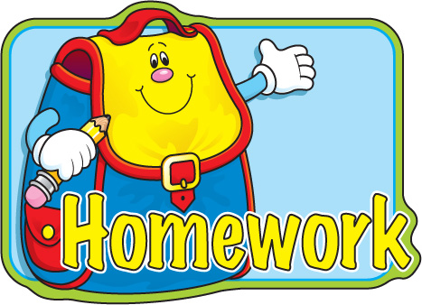

**Special Notes:**

I hope everyone is rested after the break. The holiday season is upon us, the kids and myself are excited, but we still have lots of work to do! Book orders are due Dec. 7th. There will be a Chapter 5 math test Friday – all about shapes. Chapter 7 (we skip 6) will take us up to the holiday break. Chapter 7 is all about numbers to 20. A special visitor has come to our room. Please ask your kids who he is…… ☺

Please sign

Please sign

Please sign

Please sign

**\*pack library books**